**Test Case: 01_CCP-6072_Notification succesfully completed enrollment process_SMS_Chrome**

**URL: https://sit.banamexsoaproxy1.intranet.banamex.com/uat2ps/banamex-cards-es/login**

**Credit Card Name:   ZYYYYXX ZZZZYYZXXXXZ**

**Credit Card Number: 5288430440685197**

**CVV: 119**

**Exp Date: 04/21**

**DOB:  01/01/1980**

**Step 1:**

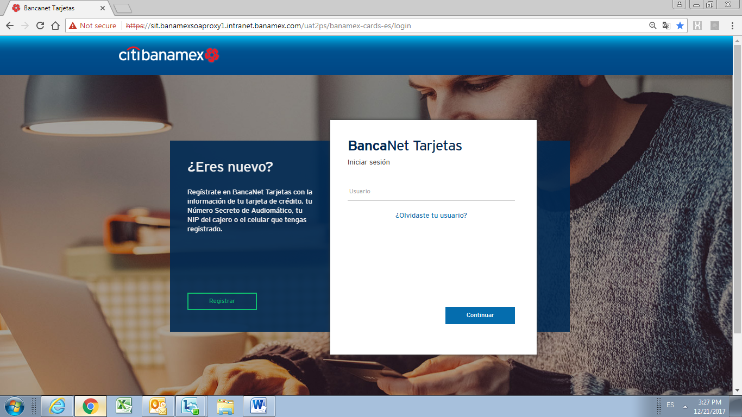

**Step 2:**

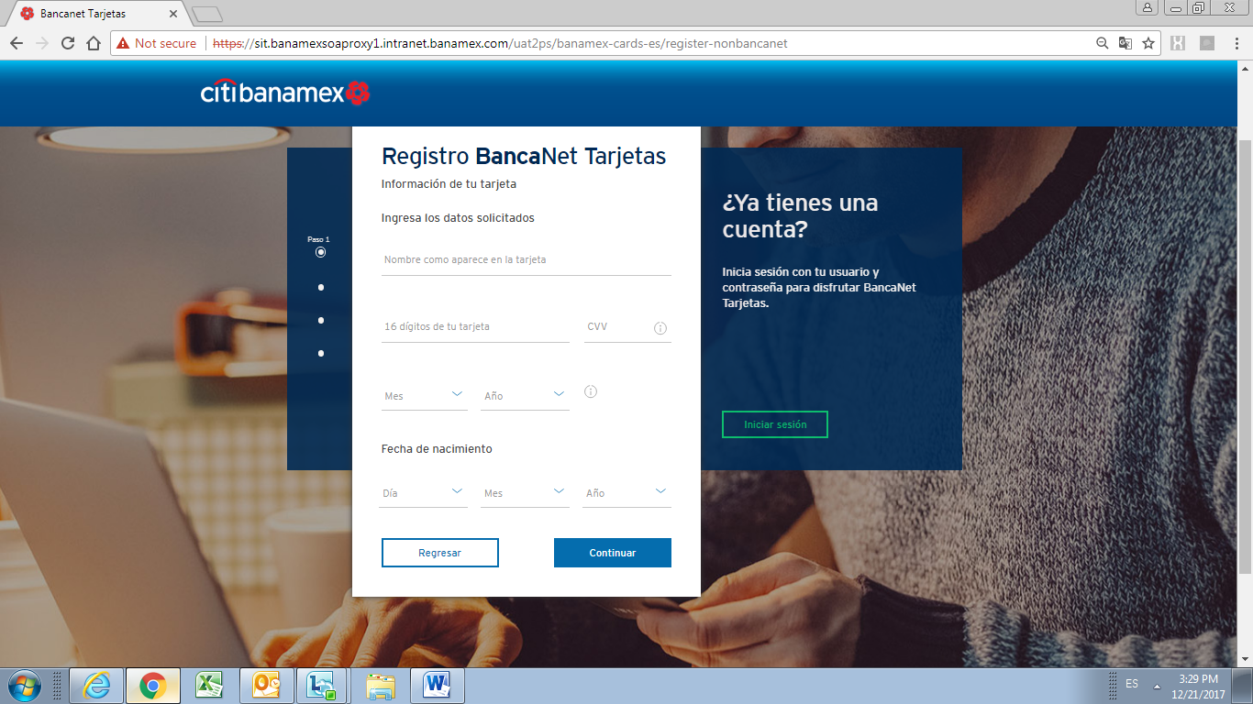

**Step 3:**

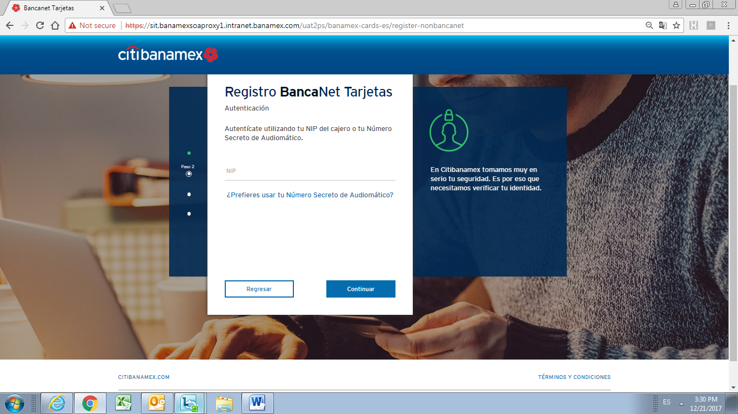

**Step 4:**

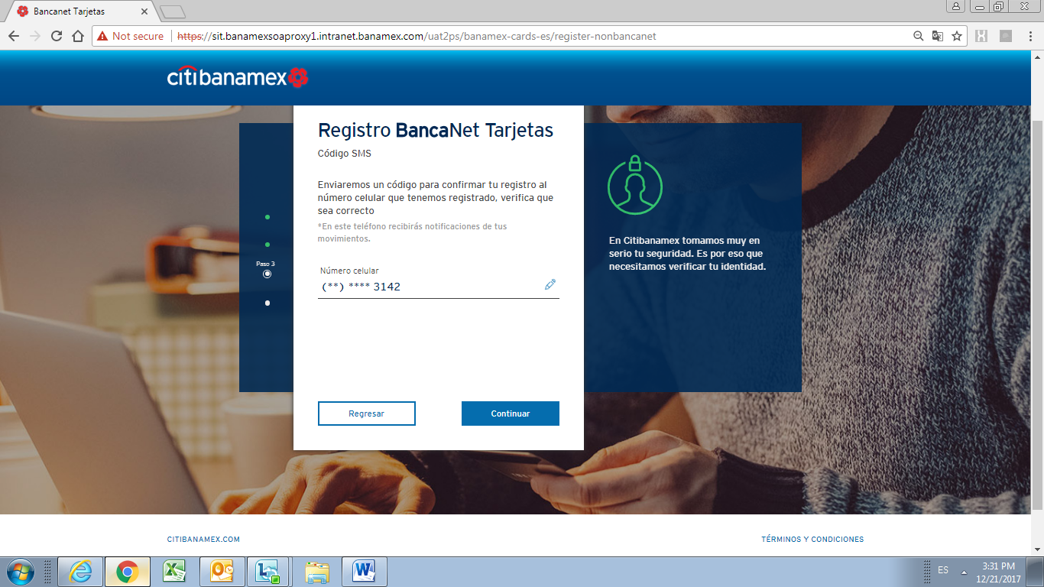

**Step 5:**

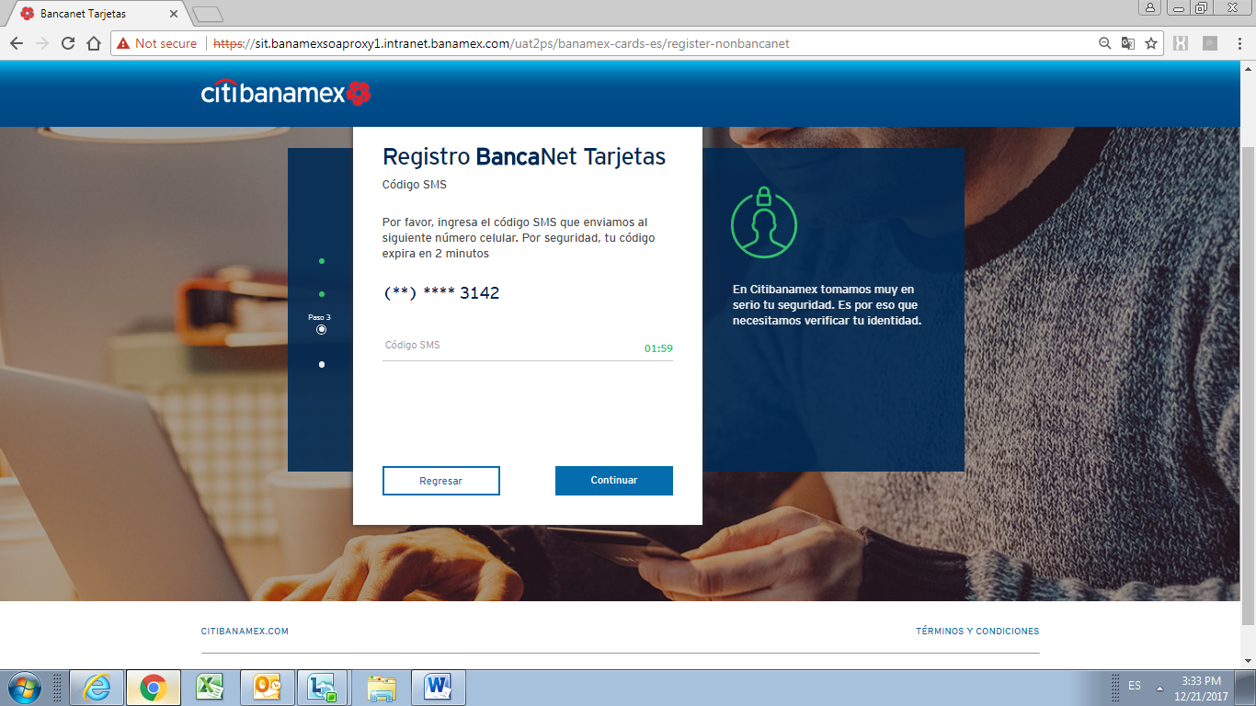

**Step 6:**

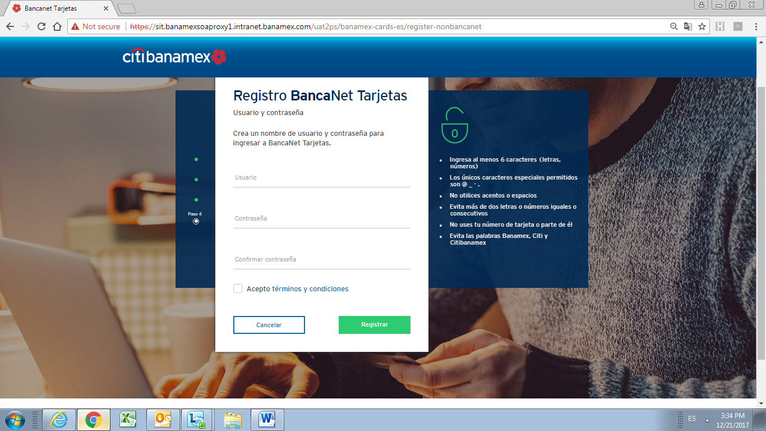

**Step 7:**

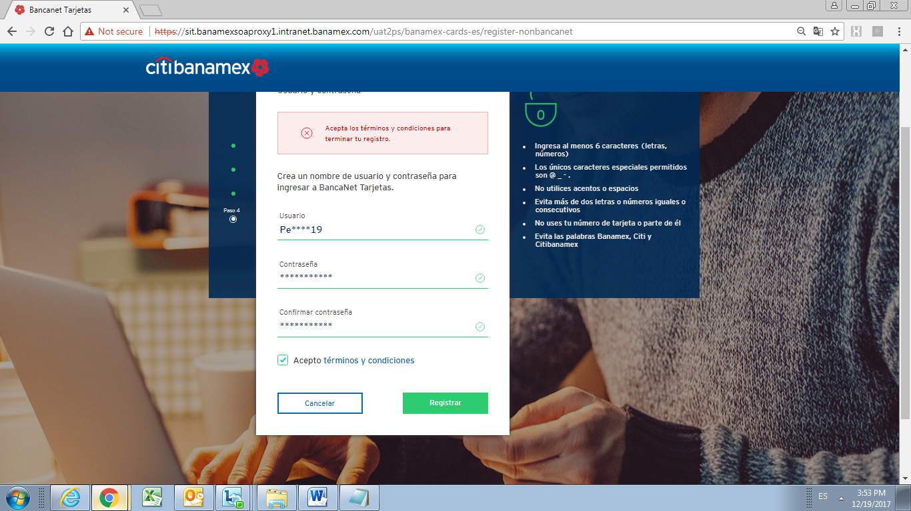

**Step 8:**

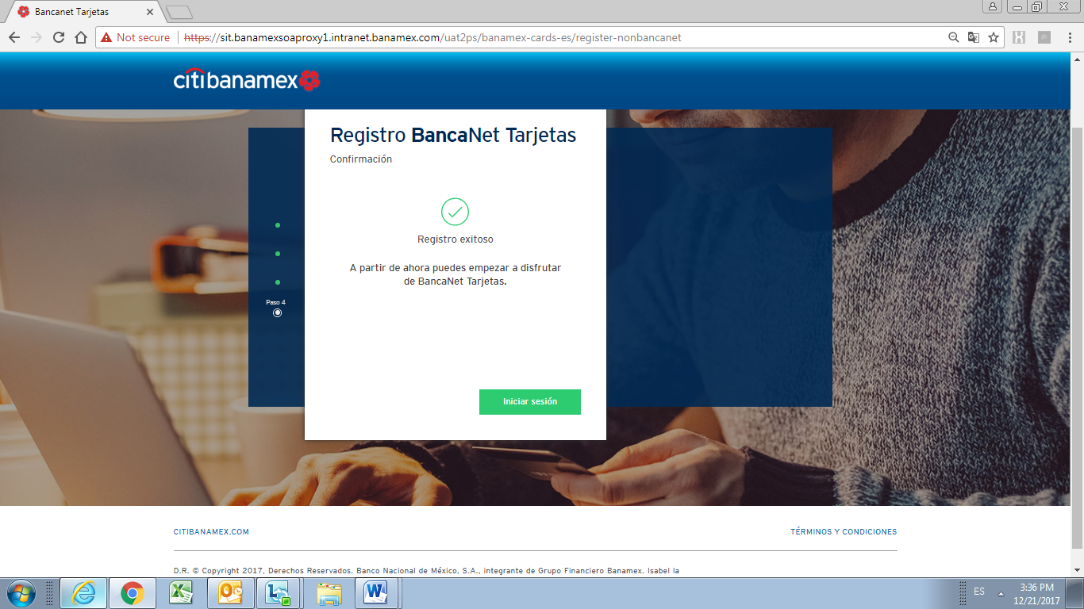

**Step 9:**